Heart Disease Prediction
Author: Rich Fox
Course: ITAI 1371 Intro to Machine Learning
Semester: Spring 2026
Instructor: Dr. Sina Nazifi
Date: April 4, 2026

Contents
Introduction & Literature Review 3
What others are doing 3
Problem Definition 4
Approach, Materials, and Methods 4
Data 4
Models 5
Tools and Libraries 5
Results 6
Discussion 8
Conclusion 9
References 11

Introduction & Literature Review
The core objective of this research is the development of a systematic process for the identification of cardiovascular risk using clinical data. Cardiovascular disease (CVD) remains the leading cause of death globally, necessitating advanced predictive models to mitigate fatalities.

What others are doing
Bhatt (2023) set out to improve CVD prediction by combining k-modes clustering with Huang initialization as a preprocessing step, then training four classifiers — Random Forest, Decision Tree, Multilayer Perceptron (MLP), and XGBoost — on a Kaggle dataset of 70,000 patient records. Continuous variables like age, BMI, and blood pressure were binned into categorical values, the dataset was split by gender to account for sex-specific disease patterns, and GridSearchCV was used for hyperparameter tuning. The MLP with cross-validation achieved the highest accuracy at 87.28%, while all models exceeded 86% accuracy and reached AUC scores of 0.94–0.95
Weng et al. (2024), a Google research team, explored whether photoplethysmography (PPG), a light-based pulse sensing technology found in most smartphones and smartwatches, could predict a person's 10-year risk of cardiovascular disease using nothing more than age, sex, smoking status, and the PPG signal itself. Traditionally, CVD risk assessments require blood pressure readings, lab work, or physical measurements, but PPG can be captured simply by placing a finger over a smartphone camera. Interestingly, related research has also explored capturing PPG signals through the eye, using smartphone or retinal cameras to detect blood volume changes in the vessels of the retina, further expanding the range of accessible, non-invasive screening methods. The Google team's deep learning model matched the performance of the standard WHO office-based risk score (C-statistic of ~71%), despite requiring none of the physical measurements the WHO score depends on. The broader vision is to enable large-scale, low-cost CVD screening in low-resource communities around the world, where access to clinics and medical equipment is limited.
Across both studies, a common theme is limited generalizability — both relied on a single dataset and neither validated their models on a fully independent external population. Bhatt's model was constrained by a relatively small dataset and excluded important lifestyle and genetic risk factors, while the Google PPG model was trained on a specialized clinical device rather than a smartphone, leaving real-world deployment unproven. The PPG deep learning features also remain difficult to interpret clinically, and eye-based retinal PPG scanning, though promising, lacks large-scale longitudinal outcome data entirely. The selected dataset for this project begins to address some of these gaps through its larger size and inclusion of lifestyle variables like smoking, physical activity, and sleep, though external validation will still be an important next step.

Problem Definition
The primary problem addressed in this documentation is whether machine learning can accurately predict or classify patients into heart disease categories based on physiological and clinical measurements. To explore this potential, the project identifies three specific research questions: Can machine learning predict heart disease using patient health measurements, can it classify patients into heart disease and no heart disease categories, and can cardiovascular risk be detected from clinical data? The project is motivated by the high prevalence of secondary health indicators in the population and the clinical relevance of predictive modeling within the health and fitness sectors. Furthermore, the prevalence of individual health factors that indicate future risk necessitates a high priority on modeling accuracy and early detection.
After running analysis of the optional features that affected the output target of Heart Disease:
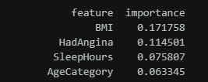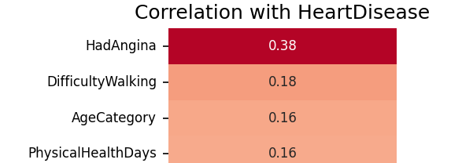
The features BMI, Difficulty Walking, Had Angina and Sleep Hours were chosen to be processed by a Binary Classification ML model.

Approach, Materials, and Methods

Data
The data used for the model was acquired from Kaggle.com: https://www.kaggle.com/code/moazwael20200/indicators-of-heart-disease/input Under Data Sources on the above link, using the 2022 data, heart_2022_with_nans.csv. This data has 445,132 records with 40 columns, and is 140 MB unzipped.

Data preparation was a critical part of this process.
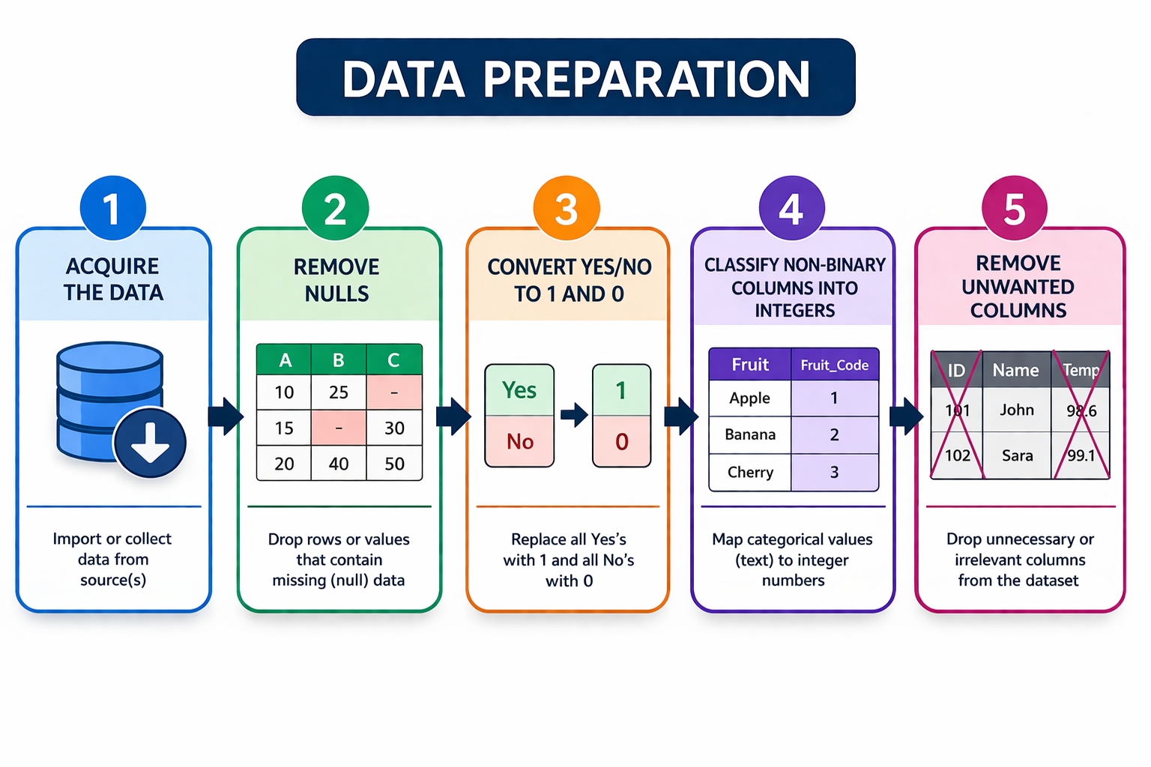

Models
Models used in this project were:
- Decision Tree
- Logical Regression
- Random Forest
- Linear SVC
- Neural Network
- Gradient Boosting
For model selection, several were selected that used CPU (instead of GPU or TPU) and could perform on a laptop in a reasonable amount of time. These were also selected because they could do Binary Classification.

Tools and Libraries
All done in VS Code using a Python Notebook.
Pandas – Importing data
NumPy – Used for editing some data
Matplotlib.pyplot – Used for graphing results
Sklearn – Used for all the heaving lifting on this project, used for training models, creating test split, and analysis of the models.

Results
The models were evaluated primarily on accuracy, but detailed metrics (precision, recall, and F1-score) were also generated to understand how well they identify actual cases of heart disease ("Yes") versus non-cases ("No").
Model | Accuracy | Precision (Yes) | Recall (Yes) | F1-Score (Yes)
Logistic Regression | 0.891 (89.1%) | 0.51 | 0.40 | 0.45
Neural Network | 0.890 (89.0%) | 0.71 | 0.02 | 0.04
Gradient Boosting | 0.889 (88.9%) | 0.54 | 0.01 | 0.02
Random Forest | 0.868 (86.8%) | 0.37 | 0.26 | 0.31
Decision Tree | 0.836 (83.6%) | 0.30 | 0.37 | 0.33
LinearSVC | 0.791 (79.1%) | 0.29 | 0.61 | 0.39

Key Findings from the Metrics
- Best Performing Model: Logistic Regression achieved the highest overall accuracy at 89.1% and the highest F1-score for the positive class (0.45), suggesting it is the most balanced model for this specific dataset.
- High Precision vs. Low Recall: The Neural Network and Gradient Boosting models showed high precision for predicting heart disease (0.71 and 0.54 respectively) but extremely low recall (0.02 and 0.01), meaning they rarely predicted heart disease even when it was present.
- Identifying Risks: While LinearSVC had the lowest accuracy, it had the highest recall (0.61) for heart disease cases, meaning it was the most successful at catching actual positive cases, though it produced more false positives.
For comparison, previous studies using a similar 70,000-instance Kaggle dataset were able to correctly identify cardiovascular disease with 90% accuracy. This top model, Logistic Regression, reached a comparable 89.1% accuracy using a filtered version of that data.
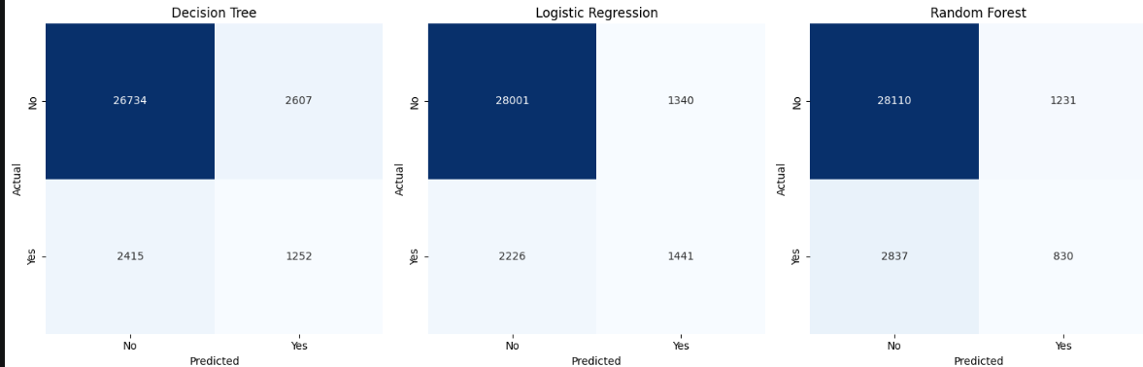
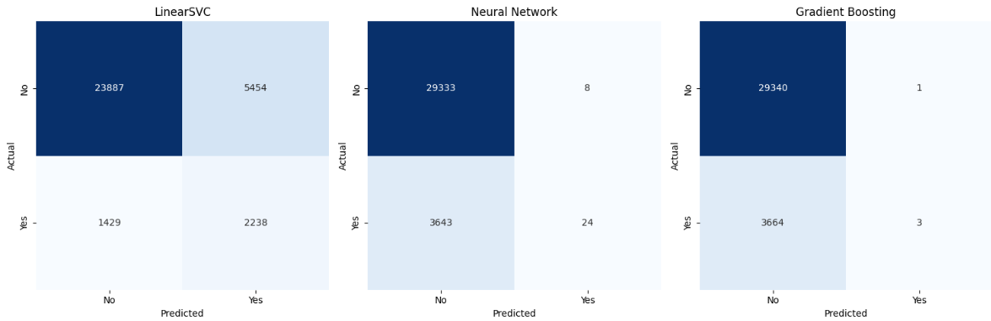

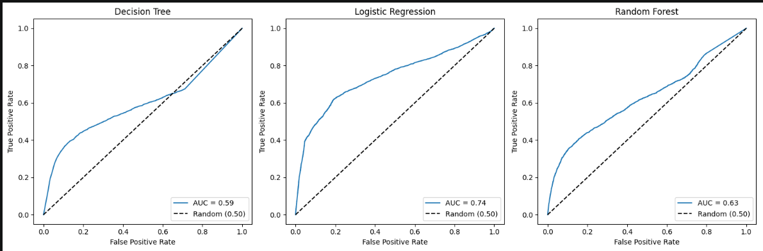
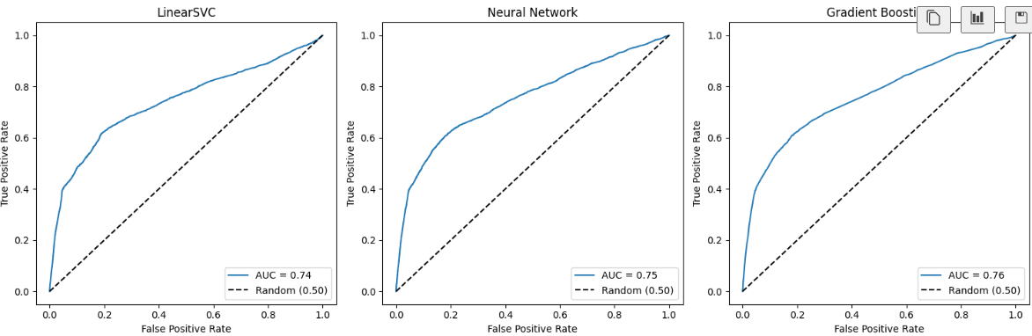

Discussion
The model performance shows a clear impact of class imbalance and highlights the tradeoff between identifying heart disease cases and avoiding false alarms. The models achieved moderate accuracy, but this metric alone is misleading because the dataset is imbalanced (many more “No” than “Yes” cases). A model can appear accurate simply by predicting the majority class most of the time.
Parameter changes had a significant impact on model behavior, particularly in how it handled the imbalance between heart disease and non-heart disease cases. Applying class_weight='balanced' increased the model’s sensitivity to the minority class, which improved recall by correctly identifying more true heart disease cases, but it also led to a higher number of false positives, reducing precision. Increasing the weight further with custom values like {0:1, 1:2} worsened this issue by overcompensating, causing the model to predict too many positive cases. Similarly, using SMOTE to oversample the minority class improved the model’s ability to detect heart disease but contributed to overprediction of positives when combined with class weighting. Adjusting the regularization parameter (C) had a smaller effect, slightly improving generalization but not significantly addressing false positives. The most effective change was tuning the classification threshold, increasing it above the default 0.5, which made the model more conservative. This reduced false positives and improved precision, though it slightly decreased recall. Overall, these results show that while data balancing techniques increased sensitivity, threshold tuning provided the most direct and effective control over the tradeoff between precision and recall.
The project faced several challenges and limitations that affected model performance and interpretation. One of the primary challenges was class imbalance, where significantly more “No Heart Disease” cases than “Yes”, which we already covered. Another limitation was the presence of categorical survey-based data, which required encoding and preprocessing; this process can introduce bias or unintended relationships, especially when categories do not have a natural numeric order. Additionally, some features were highly correlated or redundant (such as BMI, height, and weight), which can distort model interpretation and reduce clarity in feature importance. The use of Logistic Regression also imposed limitations, as it assumes a linear relationship between features and the outcome, while real-world health data is often more complex and nonlinear. Furthermore, tuning the model required careful balancing of false positives versus false negatives, which is particularly challenging in a healthcare context where both types of errors have real consequences.
Compared to state-of-the-art approaches for heart disease prediction, the models developed in this project provide reasonable baseline performance but do not reach the predictive power of more advanced techniques. State-of-the-art models—such as Gradient Boosting methods (e.g., XGBoost, LightGBM) and deep neural networks—typically achieve higher accuracy and a better balance between precision and recall because they can capture complex, nonlinear relationships and feature interactions that simpler models cannot. In this project, models like Logistic Regression required additional adjustments, such as class weighting, SMOTE, and threshold tuning, to handle class imbalance and control false positives, indicating limitations in their flexibility.
A key difference is that state-of-the-art approaches often incorporate extensive hyperparameter tuning, advanced feature engineering, and ensemble strategies, which further improve performance on imbalanced datasets. In contrast, the models used here showed sensitivity to imbalance, as evidenced by the tradeoff between high recall and increased false positives. However, despite lower overall performance, the chosen models, especially Logistic Regression, offer strong interpretability, making it easier to understand how features influence predictions. This is an important advantage in healthcare contexts, where transparency and explainability are critical. Overall, while the results do not match state-of-the-art performance, they demonstrate a solid, interpretable baseline and highlight the tradeoff between model complexity and practical usability.
The final model was developed through an iterative process of testing, evaluation, and refinement. Initial models showed reasonable accuracy but struggled with class imbalance, leading to poor detection of heart disease cases. Techniques like SMOTE and class weighting improved recall but caused too many false positives. After experimenting with these approaches, the most effective improvement came from adjusting the classification threshold, which reduced false positives while maintaining acceptable recall. The final model was chosen based on achieving a better balance between precision and recall, along with maintaining interpretability.

Conclusion
This project developed and evaluated multiple machine learning models to predict heart disease, focusing on handling class imbalance and improving prediction quality. While initial models achieved reasonable accuracy, deeper analysis showed issues with false positives and imbalanced data. Through techniques like SMOTE, class weighting, and especially threshold tuning, the final model achieved a better balance between precision and recall, making predictions more reliable and interpretable.
Through this work, I learned that accuracy alone is not a sufficient metric, especially with imbalanced datasets, and that understanding the tradeoff between precision and recall is critical. I also learned that adjusting decision thresholds can be just as impactful as changing model parameters, and that simpler models like Logistic Regression can still be valuable due to their interpretability.
For future improvements, more advanced models such as Gradient Boosting or ensemble methods could be explored to improve predictive performance. Additional feature engineering, better handling of categorical variables, and more robust hyperparameter tuning could also enhance results. Finally, using a larger or more diverse dataset could improve the model’s ability to generalize.

References
Bhatt, C.M.; Patel, P.; Ghetia, T.; Mazzeo, P.L. Effective Heart Disease Prediction Using Machine Learning Techniques. Algorithms 2023, 16, 88. https://doi.org/10.3390/a16020088
Weng, Wei-Hung, et al. “Predicting Cardiovascular Disease Risk Using Photoplethysmography and Deep Learning.” PLOS Global Public Health, vol. 4, no. 6, 2024, p. e0003204. https://doi.org/10.1371/journal.pgph.0003204

